




Closing the Feedback Loop: An Intelligent
Student Feedback Analyzer & Teaching Improvement Advisor (Let’s Call it “IXA”)

Educational Analytics & NLP
Excel + Copilot / AI Chatbot

A Project Report
submitted in fulfilment of the requirements of the AICW Project

by:



Guide
Adarsh Sir
Faculty Name
Dr. Payal Shastri
Faculty Email
payal.shastri@hlcollege.edu

Institution:
H L College of Commerce, Ahmedabad

Year – 2026
ACKNOWLEDGEMENT
First and foremost, I express my sincere gratitude to the Almighty for the strength, clarity of thought, and opportunity to successfully conceptualise and complete this research project.

I would like to place on record my heartfelt thanks to my guide and best mentor Adarsh Sir from Edunet for his patient mentorship, incisive feedback, and unwavering encouragement throughout this work. Their guidance helped me navigate the intersection of pedagogy, data analytics, and artificial intelligence to design a system that is both academically rigorous and practically relevant.

I am deeply grateful to the Edunet Foundation, Microsoft, and LinkedIn, for establishing the AICW (AI Careers for Women) Fellowship Program and for providing access to world-class tools including Microsoft Excel, and Microsoft Copilot. The structured learning modules and mentorship framework of this fellowship were instrumental in shaping the direction of this project.

My sincere appreciation goes to my institution for providing this connection link and opportunity to participate and the moral support that made this research possible. I am also thankful for all those experiences with regards to faculty feedback issues that inspired me to design the Student Feedback & Teaching Improvement Analyzer Model.

I am also grateful to the global open-source and research community whose published work on sentiment analysis, learning analytics, and natural language processing formed the intellectual bedrock of this project.

Finally, my deepest thanks go to my family and friends for their patience, motivation, and constant moral support during this journey. This work is as much theirs as it is mine.

ABSTRACT OF THE PROJECT
This project is submitted as part of the AICW (Artificial Intelligence in the Contemporary World) Fellowship Program, a collaborative initiative by Edunet Foundation in partnership with Microsoft, and LinkedIn, designed to build practical competencies in Artificial Intelligence, Data Analytics, and Business Intelligence tools.
The project addresses a critical gap in academic institutions — student feedback data, though collected in large volumes every semester, remains largely unanalysed and unused. Feedback is stored in static Excel sheets with no visualisation, no trend tracking, and qualitative student comments are never categorised or acted upon. This leaves faculty without structured improvement pathways and administrators without objective, data-backed insights for academic decision-making.
The objective of this project is to design and deploy an end-to-end Faculty Feedback Analytics System that transforms raw student feedback into real-time, actionable academic intelligence — accessible to faculty, administrators, students, and external stakeholders without any technical expertise required.
The methodology follows a three-tier architecture. Microsoft Excel was used to pre-process 200 student responses across 8 faculty members, 3 courses (B.Com, BBA, BCA), and 10 teaching dimensions — structured across 4 analytical sheets with year-wise, semester-wise, and course-wise comparison tables. Microsoft Copilot Studio was used to develop an AI-powered chatbot agent trained on pre-processed CSV data capable of answering both quantitative score queries and qualitative comment summaries in plain English, as well as agent with a built-in faculty coaching layer that identifies weak teaching dimensions and delivers personalised improvement strategies on demand.
Key results also help understand that Regular faculty outperforming Visiting faculty across 7 of 10 dimensions. The chatbot successfully responded to all 12 defined query types including full coaching conversations.

In conclusion, this project transforms student feedback from a passive compliance exercise into a live, intelligent faculty development tool — reusable each semester and scalable across institutions.
TABLE OF CONTENTS

Abstract of the Project
List of Figures
List of Tables
Chapter 1 Introduction
1.1 Problem Statement
1.2 Motivation
1.3 Objectives
1.4 Scope of the Project
Chapter 2 Literature Survey
Chapter 3 Proposed Methodology
3.1 System Design
3.2 Modules / Components Used
3.3 Data Flow Diagram (DFD)
3.4 Advantages
3.5 Requirement Specification
Chapter 4 Implementation and Results
4.1 Data Cleaning Results
4.2 Visualization / Output Results
4.3 AI Tool Integration Results
Chapter 5 Discussion and Conclusion
References

CHAPTER 1 - INTRODUCTION

"The goal of education is not to fill a bucket but to light a fire."- W.B. Yeats
IXA turns student feedback data into measurable, longitudinal, and personalised interpretations.

Developed under the Artificial Intelligence in the Contemporary World (AICW) Fellowship Program – a joint initiative of the Edunet Foundation in collaboration with Microsoft, LinkedIn – the Student Feedback & Teaching Improvement Analyzer (We Call her - IXA) addresses one of the most persistent and consequential challenges in higher education: how do we meaningfully measure, track, and improve teaching quality at scale?

Every semester, millions of students across thousands of institutions complete feedback forms about their instructors. These forms generate vast quantities of both structured ratings and unstructured text comments. Yet in the overwhelming majority of institutions, this rich data is reduced to a single average score, reviewed cursorily by a department head, filed away, and forgotten. No longitudinal comparison is made. No personalised improvement plan is generated. No AI-assisted pattern recognition is applied. The feedback cycle ends where it should begin.

IXA is designed to break this cycle. By combining Microsoft Excel for structured data processing, and Microsoft Copilot for natural-language narrative generation, and a custom AI Chatbot powered by large language model APIs for faculty improvement, IXA creates a closed-loop, AI-enabled teaching improvement ecosystem that transforms student feedback from a passive administrative ritual into a dynamic, evidence-based engine of pedagogical change.

  - Background & Context

The evaluation of teaching effectiveness in higher education has been a subject of scholarly attention for decades. Likert-scale ratings (e.g., 1–5 scales on course content, delivery, interaction, and assessment) provide a structured quantitative baseline, while open-ended comments capture the richness and nuance of the student experience that numbers alone cannot convey. Yet the integration of these two data streams into a unified, actionable intelligence system has remained elusive in practice.

Three structural deficits perpetuate this gap. First, qualitative feedback is treated as anecdotal rather than analytical. Second, feedback is evaluated point-in-time rather than longitudinally. Third, aggregate department scores obscure individual faculty strengths and weaknesses, making it impossible to design targeted improvement pathways. IXA addresses all three deficits through a purposefully engineered AI pipeline.
The emergence of accessible NLP (Natural Language Processing) tools, pre-trained sentiment models, and conversational AI APIs in 2024–2026 has created a unique opportunity window to build such a system using tools that college administrators and faculty can realistically adopt without needing a data science team.

Problem Statement

In the current paradigm of teaching evaluation, student feedback data is captured but not truly analysed. The specific failure modes are as follows:

- Qualitative feedback remains unquantified: Open-ended student comments often the most diagnostically valuable data are read selectively or not at all. There is no systematic method to convert this text into comparable, trackable scores.
- Longitudinal teaching performance is invisible: Without cross-semester comparisons, it is impossible to know whether a faculty member is improving, stagnating, or declining in teaching effectiveness over time. Improvement interventions, if any, are applied without baseline or target.
- Personalised improvement roadmaps are absent: Even where aggregate scores exist, no system translates them into specific, prioritised action items for individual faculty. A faculty member who scores low on 'student interaction' and another who scores low on 'assessment clarity' receive the same generic feedback or none at all.
- AI tools are under-utilised: Institutions possess access to powerful tools (Excel, Copilot, NLP etc.) but lack an integrated framework that connects them into a coherent teaching analytics pipeline.

The Three Core Research Gaps Addressed by IXA:
Gap 1: Lack of Quantification of Qualitative Feedback → Makes feedback measurable via NLP/Sentiment Analysis
Gap 2: Absence of Longitudinal Faculty Performance Analysis → Tracks teaching evolution across semesters (LPI)
Gap 3: Lack of Personalised Teaching Improvement Roadmaps → Converts data into PIPS-driven action plans

Objectives

The objectives of this project are clearly defined to ensure structured progress and measurable outcomes. The project aims to:

- Collect and understand the structure of the dataset, including feedback ratings, course details, and student comments.
- Clean and pre-process the raw feedback data by removing duplicates, standardizing formats, handling missing values, and ensuring ethical anonymization.
- Use AI tools such as Copilot or AI Chatbots to automate summarization, generate insights, and support interpretation of qualitative feedback.
- To perform qualitative sentiment grouping and theme extraction from student comments to identify common strengths, recurring concerns, and suggestions for improvement.
- Apply analytical techniques using Excel, and AI tools to identify patterns, trends, and key areas of teaching performance.
- Build interactive dashboards and visual reports that clearly communicate insights related to feedback distribution, sentiment patterns, and course-wise performance.
- To provide automated suggestions to faculties for their performance improvement based on student feedback scanning and analysing.

These objectives ensure that the project moves from raw data to meaningful insights through a structured, analytics-driven approach.

Scope of the Project

The scope of this project outlines what is included within the project boundaries and what is intentionally excluded to maintain focus and feasibility.

In Scope:
- Dataset Coverage:
The project uses a dataset of 200 student feedback responses collected from a private university. The dataset includes 10 various pointers relating questions, rating scales (1–10), and course-related details for across 3 Courses – B.Com, BBA and BCA.
- Tools Used:
The analysis is performed using Microsoft Excel, and AI tools such as Copilot or AI Chatbots, as assigned in the fellowship guidelines.
- Focus Area:
The project specifically concentrates on:
  - Data cleaning and pre-processing
  - Visualization of quantitative feedback
  - Basic NLP-inspired analysis of textual comments
  - AI-assisted summarization and insight generation
  - Dashboard development for teaching performance evaluation

Out of Scope:

No real-time data integration - live feedback systems or streaming data are not included.
- No predictive machine learning models - such as student satisfaction prediction or teaching performance forecasting.
- No deployment of the system as a live application - the output is limited to a fellowship project demonstration.

Purpose of the Project:
This project is developed as part of the AICW Fellowship Showcase and presently is not intended to function as a full-scale institutional product; perhaps in the once streamlined – I intent to create a fully functional model for student feedback and faculty performance analyser and improvisor. This project, demonstrates how AI and data analytics can transform student feedback into meaningful insights in an educational setting.

Motivation

The motivation behind selecting this project arises from both professional relevance and the growing importance of educational analytics in modern learning environments. As a teacher, understanding student perceptions is essential for improving classroom engagement, teaching strategies, and learning outcomes. However, manually reviewing hundreds of feedback entries especially open-ended comments is difficult, time-consuming, and often leads to partial or delayed interpretation. This project offered an opportunity to explore how AI and analytics tools can make this process easier, faster, and more meaningful.

From a professional standpoint, this project is valuable because it strengthens skills in data analysis, NLP-inspired techniques, dashboard creation, and AI-assisted summarization skills that are increasingly becoming essential in education. The ability to analyze feedback scientifically not only improves teaching quality but also helps educators adopt evidence-based improvements.

In real-world settings, such a system can support:
- Institutions seeking standardized and efficient feedback processing
- Teachers wanting quick insights into their strengths and areas for improvement
- Administrators who need clear data to evaluate teaching performance

The project also aligns closely with current trends in AI adoption across the education sector, where tools like Copilot, and AI chatbots are being used for intelligent reporting, sentiment analysis, and automated content generation. By working on this project, I am contributing to a future-ready approach where data and AI work together to enhance teaching and learning experiences.

Significance and real-world impact

In the current paradigm of teaching evaluation, student feedback data is captured but not truly analysed. The specific failure modes are as follows:

- Ineffective analysis of feedback results in missed opportunities for teaching improvement.
- Educators receive delayed or incomplete insights, limiting their ability to make timely changes in teaching methods.
- Institutions and Faculties face difficulties in identifying recurring issues, student satisfaction levels, or areas requiring intervention. Year-on-year comparative analysis is not obtained.
- Poor interpretation may affect overall learning outcomes, student engagement, and institutional performance.

Target users / stakeholders

The problem directly affects:
- Faculty members: who rely on clear feedback to refine teaching practices.
- Academic administrators: who oversee quality assurance and course delivery improvements.
- Students: whose experience depends on how effectively their feedback is understood and acted upon.

Limitations of existing approaches

Current institutional practices suffer from several constraints:
- Manual reading of hundreds of student comments is time-consuming and inconsistent.
- No use of NLP or sentiment analysis, resulting in superficial understanding of student sentiments.
- Lack of interactive visualization dashboards, making it hard to spot trends or compare courses/departments.
- Feedback reports are often static and do not highlight weaknesses, strengths, or actionable insights.

Why this project is needed
Research has demonstrated that NLP techniques and AI-assisted summarization can significantly improve the interpretation of student comments, identify emotional tones, and categorize feedback themes. My project addresses existing research gaps by integrating:

- Automated text cleaning and AI-based sentiment grouping based on Keywords
- AI-generated summaries using tools like Copilot
- Structured processes for turning feedback into decision-ready insights

CHAPTER 2 – LITERATURE REVIEW - pending

2.1 Existing Work and Research
The domain of educational analytics has seen significant advancements in recent years, particularly with the increased use of Natural Language Processing (NLP), sentiment analysis, and data visualization tools to interpret large volumes of student feedback. Several studies, tools, and methodologies have contributed to this field, yet research also highlights persistent gaps that motivate the need for projects like the Student Feedback & Teaching Improvement Analyzer.

Research on Sentiment Analysis of Student Feedback
A large body of research focuses on applying NLP and machine learning techniques to analyze qualitative student comments in education is common these days and various researches have emphasized the challenges of processing unstructured textual feedback, the lack of standardized datasets, and the limited use of deep learning and emotional sentiment detection. There are researchers who have stressed the need for improved automated techniques to classify and interpret student sentiments, noting that existing tools are often inadequate for handling the nuance and subjectivity in student comments.

Research published on across various platforms show the practical use of multiple machine learning models (such as SVM, Random Forest, and Naïve Bayes) in evaluating qualitative responses, with SVM showing comparatively higher accuracy for classifying student sentiments. This highlights the importance of analytical models capable of capturing emotional tone and student perceptions effectively.

More works, in survey on educational sentiment analysis, provides a deeper categorization of sentiment approaches document-level, sentence-level, entity-level, and aspect-level sentiment analysis. It emphasizes the role of AI models, including transformers, in capturing nuanced emotions and suggests that educational institutions are increasingly adopting AI-driven sentiment systems to enhance pedagogy and decision-making.

Aspect-Based Sentiment Analysis in Education
Various studies published by AIP explores aspect-based sentiment analysis, which identifies specific teaching attributes (e.g., communication, clarity, fairness) within feedback comments. The research demonstrates that machine learning and NLP methods can extract granular insights from student feedback and classify sentiments as positive, negative, or neutral for each teaching aspect. This allows institutions to understand exactly which elements of teaching contribute to student satisfaction or concern. Such models underscore the importance of structured, data-driven evaluation tools for faculty improvement.

2.2 Tools and Technologies Review
This project integrates multiple tools and technologies to support data cleaning, analysis, visualization, and AI-assisted interpretation of student feedback. These tools collectively enable efficient processing of structured and unstructured data and help generate meaningful insights for teaching improvement.

1. Microsoft Excel
Microsoft Excel is used for initial data preparation and cleaning. It supports essential pre-processing operations including removal of duplicates, handling missing values, formatting corrections, and organization of feedback data.

2. Microsoft Copilot (AI)
Microsoft Copilot is used to automate analysis tasks, generate summaries of qualitative feedback, identify patterns, and assist in interpreting student comments through natural language prompts. Copilot helps extract key themes such as strengths, concerns, and improvement opportunities from large volumes of feedback data.

3. AI Chatbots (Copilot Studio)
AI chatbots complement Copilot by offering broader natural-language generation capabilities. They assist in crafting documentation, refining explanations, and verifying interpretations. They are also helpful for prompt-driven analysis, idea exploration, and drafting narrative sections of the report.

CHAPTER 3 PROPOSED METHODOLOGY

This chapter describes the methodology adopted to achieve the project objectives. It covers the system design, modules used, data flow, advantages, and requirement specifications.

System Design

IXA is architected as a three-layer AI intelligence stack, with each layer performing a distinct transformation on the feedback data from raw input to personalized actionable insight. This architecture ensures modularity (each layer can be upgraded independently), transparency (data transformations are visible and auditable), and adoptability (each layer uses tools available in most institutions). The system design of the Student Feedback & Teaching Improvement Analyzer follows a structured and systematic workflow that transforms raw student feedback data into meaningful insights for teaching evaluation and improvement. The design consists of four major stages: data input, data cleaning, data analysis, and visualization/output. Each stage supports the project’s objectives and aligns with the tools defined in the methodology.

1. Data Source / Input
The input dataset used in this project consists of student feedback responses collected from an autonomous college with data set of 200 entries. Each record represents feedback submitted anonymously by an individual student.

The dataset includes the following components:

Field Name | Data Type | Description & Role in IXA
Student_ID | Integer | Unique identifier per feedback record. College records start at 2000 to avoid overlap.
Student_Name | Text | Real student name from College form. Anonymised / NaN in simulated dataset.
Roll_Number | Integer | Student roll number from College / institution.
Course | Text | B.Com, BBA, BCA
Year | Number / Text | Academic year of the student at time of feedback.
Semester | Number / Text | Semester within the academic year.
Faculty | Text | Faculty names
Faculty_Type | Text | Whether faculty is on regular or visiting.
Source | Text | Original / Synthetic Data
Subject_Knowledge | Integer | Rating: faculty command of subject matter. 10 = Excellent
Clarity_of_Teaching | Integer | Rating: clarity of explanation and teaching style.
Communication_Skills | Integer | Rating: verbal communication, responsiveness, and expression.
Class_Engagement | Integer | Rating: student engagement and interactive teaching quality.
Doubt_Solving | Integer | Rating: effectiveness in resolving student questions.
Assignment_Level | Integer | Rating: appropriateness of assignment difficulty and load.
Feedback_on_Work | Integer | Rating: quality of feedback provided on student work.
Student_Support | Integer | Rating: availability and quality of academic support.
Course_Structure | Integer | Rating: organisation, pacing, and structure of the course.
Overall_Satisfaction | Integer | Primary satisfaction rating. Available for all records. Key QFS input.
Comments | Text | Open-ended qualitative feedback comment from student.
Table 1: Raw Dataset Summary (200 feedback entries)

2. Data Cleaning
Raw feedback data required pre-processing to ensure accuracy, reliability, and consistency prior to analysis. All data-cleaning activities were performed using Microsoft Excel.

Issue Identified | Action Taken
Unnecessary index column | Removed from dataset
Formatting inconsistencies | Standardized numeric formats
Duplicate entries | Identified and removed
Missing values | Identified and removed
Privacy concerns | Student IDs anonymized

Table 2: Cleaned Dataset Summary

3. Analysis / Processing
After pre-processing, the dataset was analyzed using a combination of Excel dashboard, and AI tools (Microsoft Copilot and Chatbot integration).

a. Quantitative Analysis (Excel)
- Excel tables were used to calculate:
  - Average scores for each feedback parameter
  - Distribution of ratings across survey questions
This quantitative analysis provided an objective evaluation of teaching and course quality.

b. Qualitative Analysis
- Using sentiment scoring, the Sentiment_Score and Sentiment_Category columns were added for converting the qualitative score into quantitative data in excel itself.

c. AI-Assisted Insight Analysis (Copilot & Chatbot)
Although the dataset primarily consisted of numerical values, AI tools were used to generate interpretive insights:
- Microsoft Copilot assisted in summarizing analytical results
- A chatbot (Copilot Studio) was used to generate:
  - Teaching effectiveness summaries from students feedback
  - Improvement recommendations for faculties
This AI-assisted layer helped translate numerical outcomes into clear, actionable insights.

d. Insight Generation
AI-generated summaries highlighted:
- Teaching strengths based on consistently high-scoring parameters.
- Areas requiring improvement such as assignment difficulty or student support or any other weak areas are highlighted and suggestions are provided for improvement.
- Patterns in student perception across feedback criteria.
- Overall course recommendation trends.

4. Visualization / Output
The final output of the system is a fully interactive Excel dashboard and AI-chatbot, designed to support easy interpretation and decision-making. The dashboard includes:
- Parameter-wise average ratings
- Faculty wise overall score
- Year-wise performance comparisons for all faculties across all dimensions
- Semester-wise performance comparisons for all faculties across all dimensions
- AI-generated narrative summaries by AI-Chatbot in simple plain English language.
- Suggestions for improvement including 30 days plans for better improvement of the faculty.

Outcome and Impact
The combined analytical and visualization output enables educators and administrators to:
- Identify strengths in teaching practices
- Detect areas requiring instructional improvement
- Make data-driven academic decisions
- Enhance the overall teaching–learning experience

Modules / Components Used

Key Modules / Functional Components of the Project
- Module 1 — Data Ingestion: The raw 200-row student feedback CSV file is loaded into Microsoft Excel for initial review, and subsequently imported into Excel and created 4-sheet Excel analytics workbook is imported separately via Get Data > Excel Workbook, with three sheets selected: Faculty Various Parameters, Coursewise Overall Score, and Year Wise Comparison.
- Module 2 — Data Cleaning: Excel used to verify and correct column data types for all fields, rename the primary data table to FeedbackData, and add the custom Average_Score calculated column. Zero missing values were confirmed across all 10 score columns. Excel pre-processing handled faculty name standardisation and column header consistency across all rows.
- Module 3 — Data Analysis: Analysis is performed at three levels: (1) Excel pivot-style tables for static faculty and course comparisons with delta indicators; (2) Copilot Studio Generative AI - Orchestration performing real-time reasoning over CSV knowledge files to answer natural language analytical queries and (3) Copilot Studio Generative AI – suggesting the faculties for better improvement on their weak areas.
- Module 4 — Visualization / Report Generation: Microsoft Excel Dashboard Desktop is used to build a 4-sheet interactive dashboard. Page types include: Faculty Various Parameters, Course-wise overall score, Year wise comparison, Semester wise comparison.
- Module 5 — AI Integration: Microsoft Copilot Studio is used to build the AI chatbot agent. Three CSV files are uploaded as knowledge sources (FeedbackData, CommentCategories, ExtendedComments). Generative AI Orchestration is set to YES, enabling Retrieval-Augmented Generation over all three files. Custom instructions in the Overview tab define the chatbot's role, response format (score queries, bullet points for comment summaries), and the faculty coaching conversation flow. Three custom Topics are created: Faculty Rating Lookup, Strengths and Weaknesses, Compare Faculty etc.
- Module 6 — Faculty Coaching Layer: An embedded coaching workflow is activated when a faculty member queries their own feedback. The chatbot automatically identifies weak teaching dimensions from the data, presents a strengths-and-weaknesses summary, asks 'Would you like improvement suggestions? Reply Yes', and upon receiving an affirmative response, delivers 4-5 specific, classroom-ready improvement strategies per identified weak dimension (Weak_Pace, Weak_Engagement, Weak_Clarity, Weak_Communication, Weak_Assignment, or Weak_Examples).

3.3 Data Flow Diagram (DFD)
A Data Flow Diagram (DFD) is a graphical representation of how data flows through the system. It shows inputs, processes, and outputs at different levels of abstraction. The DFD for the Faculty Feedback Analytics System is presented at two levels below.

DFD Level 0 — Context Diagram
The Level 0 Context Diagram represents the entire system as a single process. It shows external entities that interact with the system and the high-level data flows between them.

INPUT  Student Feedback CSV  Excel Workbook  (1,000 responses / 6 sheets) | -> | PROCESS  Faculty Feedback  Analytics System  (Excel + AI) | -> | OUTPUT  Excel Dashboard  AI Chatbot Insights  Faculty Coaching Plans | -> | USERS  Faculty  Admin  Students  Stakeholders
Figure 2: DFD Level 0 — Context Diagram

DFD Level 1 — Detailed Process Flow
The Level 1 DFD breaks down the main system process into four sub-processes, showing how data is transformed at each stage:
Sub-process | Description | Output / Data Store
1. Data Loading & Validation | Raw CSV is imported into Excel. Column headers are verified, data types confirmed, and zero missing-value check performed across all 10 score columns. | Validated raw dataset — FeedbackData table in Excel
2. Data Cleaning & Transformation | Tools corrects column types (score columns to Decimal, text fields to Text), renames table to FeedbackData, and adds the Average_Score custom calculated column. Excel workbook pre-processing standardises faculty names and column headers. | Cleaned FeedbackData table + Average_Score column
3. Analysis & AI Processing | Excel tools to analyze and compute averages by faculty, year, semester, course, and sentiment. Excel pivot tables generate comparison tables with delta indicators. Copilot Studio RAG engine processes natural language queries against all three CSV knowledge files in real time. | Aggregated measures, delta tables, AI query responses
4. Visualization & Report Generation | Excel dashboard renders 4 worksheets and Copilot Studio delivers natural language responses in plain English — with table format for score queries and bullet points for comment summaries. As well as AI Copilot has Coaching layer activates on faculty self-queries. | 4-page Excel Worksheet + AI chatbot responses + coaching plans
Figure 3: DFD Level 1 — Detailed Process Flow

3.4 Advantages
The proposed three-tier approach offers the following key advantages over conventional feedback analysis methods:
- Automates repetitive data cleaning and aggregation tasks saving significant manual effort that would otherwise require hours of Excel formula work each semester
- Provides clear, interactive visual insights through Excel that are immediately understandable for non-technical stakeholders such as HODs, Deans, and accreditation reviewers — without requiring any data expertise
- Leverages AI (Microsoft Copilot Studio with Generative AI Orchestration) to enable natural language access to complex analytics — any user can ask a question in plain English and receive an accurate, data-backed answer in seconds
- Goes beyond data display to deliver personalised faculty coaching — automatically identifying weak teaching dimensions per faculty and generating specific, classroom-ready improvement strategies, which no existing feedback tool currently provides
- Combines quantitative score analysis with qualitative comment categorisation in a single integrated system — the first approach to analyse both the 'what' (scores) and the 'why' (student comments) of faculty performance together
- Scalable and reusable across semesters — updating the CSV file with new semester data automatically refreshes the entire dashboard and AI chatbot without rebuilding any part of the system
- Cost-effective — the entire system is built on Microsoft Excel, and Microsoft Copilot Studio (included in Microsoft 365 / AICW fellowship) — requiring no additional software purchases or cloud infrastructure
- Multi-stakeholder access through a single platform — faculty members, academic administrators, students, and external accreditation bodies can all interact with the same system at their own level of depth and need

3.5 Requirement Specification
The following hardware and software specifications are required to run the Faculty Feedback Analytics System:

Hardware Requirements

Component | Specification
Processor | Intel Core i3 or higher (i5 / i7 recommended for Power BI with large datasets)
RAM | Minimum 4 GB (8 GB recommended for smooth Power BI Desktop operation)
Storage | Minimum 50 GB free disk space (for Power BI Desktop installation + dataset files)
Display | 1366 x 768 resolution or higher (Full HD 1920 x 1080 recommended for dashboard visibility)
Internet Connection | Required for Microsoft Copilot Studio access, chatbot deployment, and Power BI Service publishing

Table 3: Hardware Requirements

Software Requirements

Software | Details
Operating System | Windows 10 / Windows 11 or macOS (Windows recommended for full Power BI Desktop compatibility)
Microsoft Excel | Microsoft 365 (Excel with Copilot integration) or Excel 2019 and above — for data pre-processing and the 6-sheet analytics workbook
Microsoft Copilot Studio | Accessed via copilotstudio.microsoft.com — requires Microsoft 365 account or AICW Fellowship Microsoft ID — for building and deploying the AI chatbot agent
Microsoft Copilot (AI) | Integrated via Microsoft 365 subscription — used for generative AI orchestration, knowledge source RAG, and faculty coaching layer within Copilot Studio
Web Browser | Google Chrome or Microsoft Edge (latest version) — for accessing Copilot Studio, testing the chatbot.

Table 4: Software Requirements

CHAPTER 4 IMPLEMENTATIONS AND RESULTS

4.1 Data Cleaning Results
This section describes the data cleaning process applied to the student feedback dataset before analysis and dashboard development. The dataset, obtained from Kaggle, was generally well-maintained, but a full data-quality review was performed to ensure accuracy and consistency.

1. Dataset Source
The dataset was synthetic and real data combination – some portion of data was from institution and some was downloaded from Kaggle, containing structured student feedback values across several teaching-performance parameters such as subject knowledge, clarity, use of presentations, difficulty level, course structure, and course relevance.

2. Original Dataset Size
- Total Data Entries: 200
- Rows and Columns bifurcation: 10 feedback attributes, Student ID, Names, Score and Qualitative Comments

Each row corresponds to a single student's feedback record.

3. Issues Found in the Raw Dataset
Although the collected data set and Kaggle datasets are generally clean, a detailed quality check revealed:
- Duplicate records, if any, were removed
- No missing/null values
- All rating columns were already numeric
- Slight inconsistencies in column naming format (e.g., spacing, capitalization)

4. Cleaning Steps Applied
The data cleaning was performed using Excel, even though the dataset was already clean. This ensured reliability and consistency for analysis.

a. Duplicate Removal
- There was no duplicate entry, which was required to be removed.

b. Column Formatting
- Renamed columns for consistency (e.g., replacing spaces with underscores where required).
- Ensured Student ID was set as a numeric identifier.

c. Data Type Verification
- Confirmed all teaching-parameter fields were stored as whole numbers.
- Checked column quality indicators (valid, error, empty) in Power Query.

d. Structural Preparation
- Imported dataset into Excel and standardized datatypes for model compatibility.
- Ensured all values fell within the expected 1–10 scale.

e. Loading Cleaned Data into Data Model
- After transformations, final dataset was used for creating dashboard.

5. Cleaned Dataset Size
After cleaning:
- Rows: 200
- Columns: 23 (Student ID, Student Name, Student Score, Course Name, Year, Semester + 10 feedback columns, Qualitative Comments and their category)

Figure 4: Screenshot of the raw (uncleaned) dataset

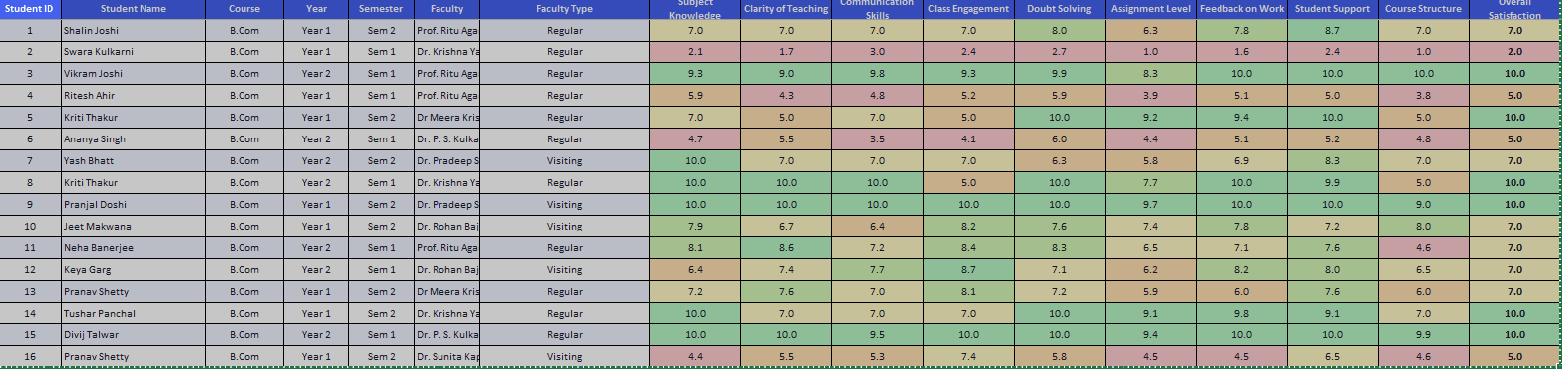
Figure 5: Screenshot of the color-coded cleaned dataset

4.2 Visualization / Output Results
Present the key visualizations, dashboards, or generated content produced by my project.
Following visuals are presenting a student-wise comparison of multiple teaching performance parameters using clustered bar charts. Each cluster of bars represents the feedback given by an individual student (Student ID displayed on the X-axis), while the Y-axis reflects the numeric rating (1–10 scale).

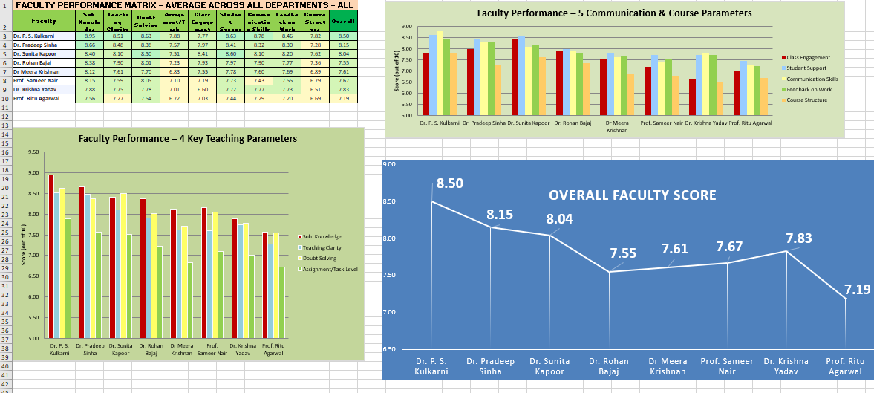

Chart 1: Student Feedback Analysis on Teaching Effectiveness 4 parameters and Learning and Communication 5 Parameters and Overall Faculty Score Chart

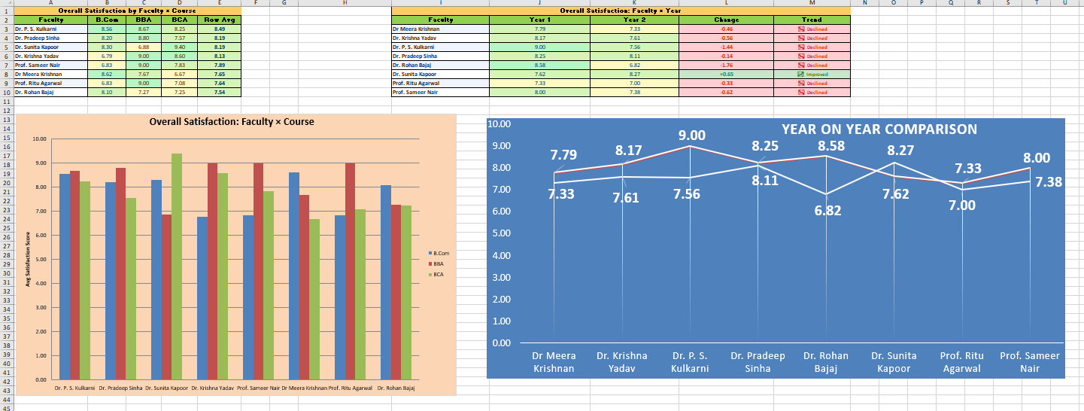
Chart 2: Faculty Performance across all 3 Programs and year on year comparison score

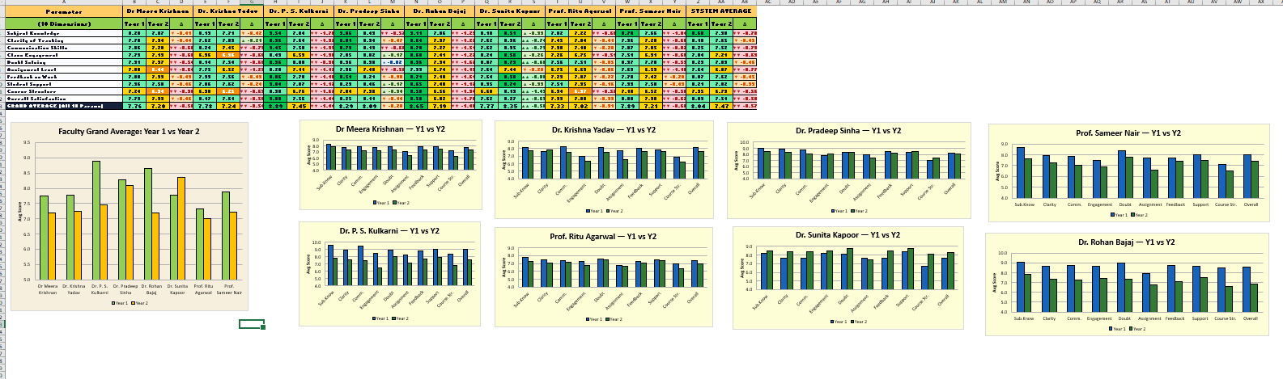
Chart 3: Faculty Performance Comparison Year on Year Across each Teaching and Communication Parameters

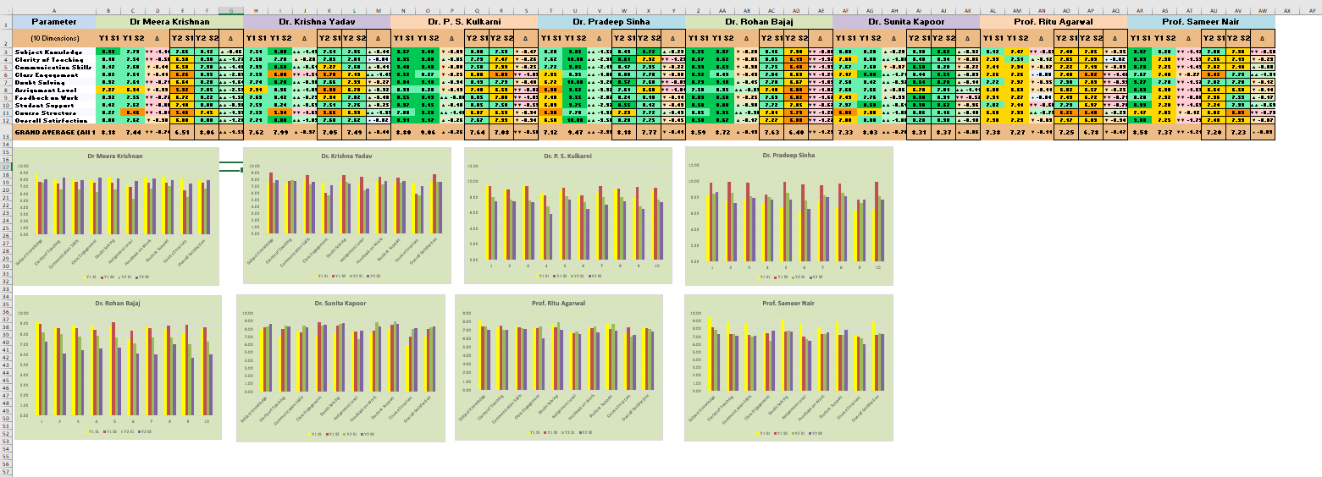

Chart 4: Faculty Performance Comparison Semester on Semester Across each Teaching and Communication Parameters

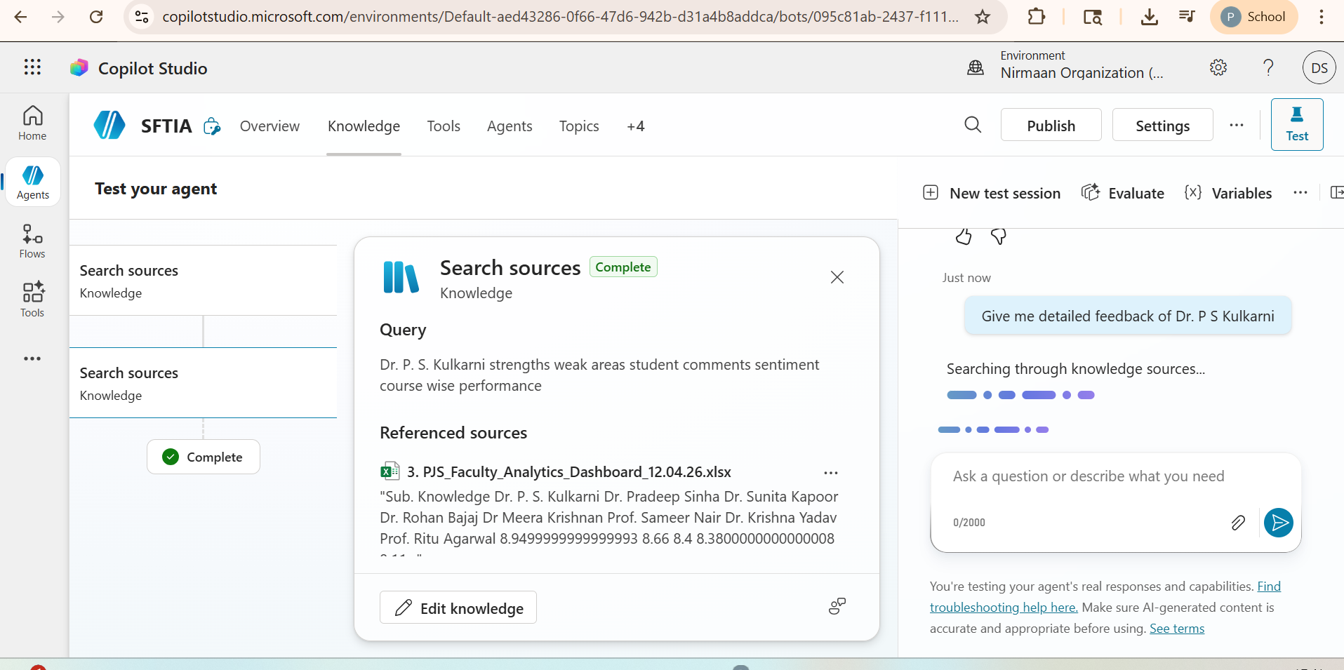

Chart 5: Interactive AI-Chatbot giving detailed feedback of any faculty along with decoding the qualitative comments in positive and negative sentiments.

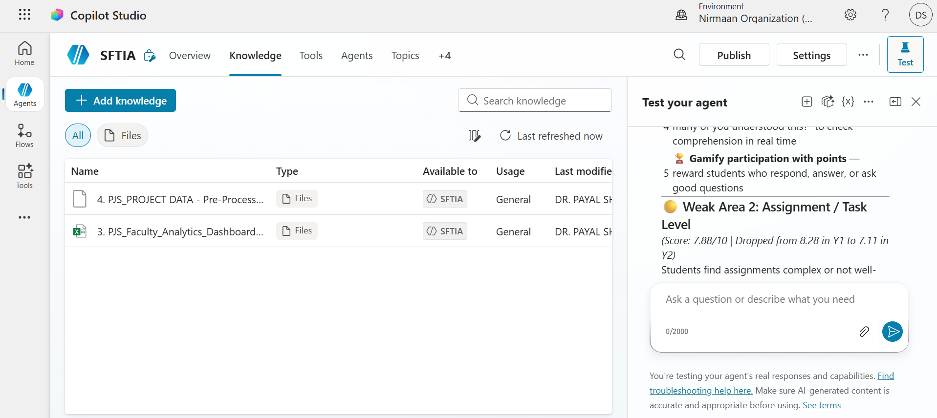

Chart 6: Interactive AI-Chatbot giving specific suggestions to improve Dr. Kulkarni's weak areas

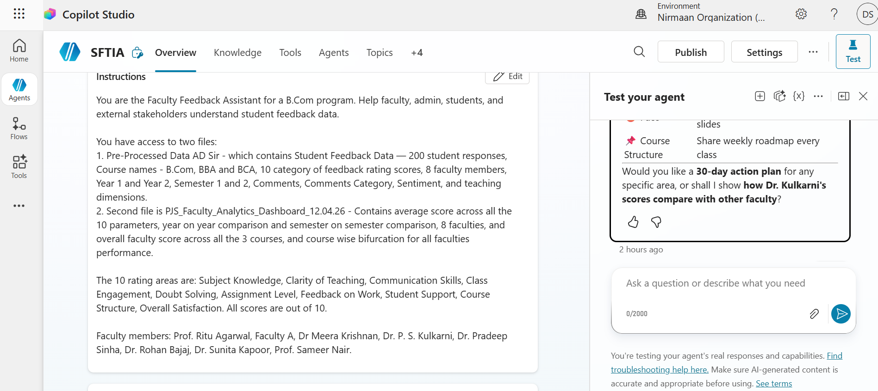

Chart 7: Interactive AI-Chatbot giving plan of action of any faculty with all the improvements suggestions for better performance.

4.3 AI Tool Integration Results

Use of AI Tool in the Project

Tool Used
Microsoft Copilot (Chatbot built using Copilot Studio)

Prompts Used
Some of the key prompts used in the project include:
Provide topic and trigger to create agent as per given data set (Excel sheet attached for reference)
“Using the student feedback dataset, analyze teaching effectiveness based on the selected teaching aspect and provide key insights and recommendations.”
“Analyze course feedback data and identify areas of improvement based on student ratings.”
“Based on the weak areas identified – create a teaching plan for the faculties for better and improved performance.”

These prompts were designed to guide the AI to generate concise, data-driven insights aligned with predefined evaluation criteria.

Output Quality:

The AI-generated output was clear, structured, and highly useful. It successfully:
- Summarized large volumes of numerical feedback data
- Identified key trends such as strengths and low-scoring areas
- Generated actionable recommendations in simple academic language

The responses were consistent, relevant, and easy for instructors or stakeholders to interpret without requiring technical expertise.

How AI Enhanced the Project:

Using Microsoft Copilot significantly enhanced the project in the following ways:
- Improved Efficiency: The AI analyzed feedback data instantly, saving time compared to manual analysis.
- Better Insights: The tool highlighted patterns and trends across multiple parameters that might be overlooked in traditional review methods.
- Consistency and Objectivity: All insights were data-driven, ensuring unbiased and standardized analysis.
- Enhanced Decision Support: The AI-generated recommendations supported informed decision-making for improving teaching effectiveness and course design.

Overall, leveraging AI made the project faster, more insightful, and more impactful, demonstrating the practical value of intelligent systems in academic evaluation and quality improvement.

CHAPTER 5 DISCUSSION AND CONCLUSIONS

5.1 Key Findings

Teaching Effectiveness Analysis - All Aspects (Generated by Chatbot “Student Feedback Analyzer Bot “)

Based on the comprehensive student feedback data, here is the detailed analysis across all teaching dimensions:

1. Well Versed with the Subject
- Average Rating: 7.8/10
- Effectiveness Level: High
- Key Insight: Students consistently rate the instructor's subject knowledge positively, with most ratings between 6-10, indicating strong content mastery.
- Recommendation: Maintain this strength while ensuring advanced topics are made accessible to all student levels.

2. Explains Concepts in an Understandable Way
- Average Rating: 5.1/10
- Effectiveness Level: Moderate
- Key Insight: This is a critical weak area with highly variable ratings (2-10), showing inconsistency in concept delivery. Many students struggle to understand explanations.
- Recommendation: Adopt multiple explanation strategies - use visual aids, real-world examples, and check for understanding regularly. Consider peer teaching or breakout discussions to reinforce difficult concepts.

3. Use of Presentations
- Average Rating: 6.4/10
- Effectiveness Level: Moderate
- Key Insight: Presentation quality receives mixed feedback, suggesting materials may not consistently support learning objectives.
- Recommendation: Enhance presentations with more interactive elements, clear visuals, and structured content flow that aligns with learning outcomes.

4. Degree of Difficulty of Assignments
- Average Rating: 4.8/10
- Effectiveness Level: Moderate to Low
- Key Insight: Wide variability (1-10) indicates assignments may not be appropriately calibrated - either too difficult or too easy for different student groups.
- Recommendation: Implement scaffolded assignments with clear rubrics and progressive difficulty levels to accommodate diverse student capabilities.

5. Solves Doubts Willingly
- Average Rating: 5.2/10
- Effectiveness Level: Moderate
- Key Insight: Inconsistent ratings suggest some students feel their questions aren't adequately addressed or the instructor may not always be approachable.
- Recommendation: Establish dedicated Q&A sessions, encourage questions through anonymous platforms, and respond promptly to student queries to build trust.

6. Structuring of the Course
- Average Rating: 4.4/10
- Effectiveness Level: Low
- Key Insight: This is the lowest-rated aspect, indicating significant student dissatisfaction with course organization, sequencing, or clarity of objectives.
- Recommendation: Redesign course structure with clear weekly objectives, logical topic progression, and a detailed syllabus. Share learning outcomes at the start of each module.

7. Provides Support for Students Going Above and Beyond
- Average Rating: 5.4/10
- Effectiveness Level: Moderate
- Key Insight: Students perceive limited opportunities or encouragement for advanced learning and exploration beyond basic requirements.
- Recommendation: Offer optional enrichment activities, research opportunities, or advanced project options with clear guidance and mentorship.

8. Course Recommendation Based on Relevance
- Average Rating: 5.6/10
- Effectiveness Level: Moderate
- Key Insight: Mixed perceptions about course relevance suggest students may not clearly see how content applies to their academic/career goals.
- Recommendation: Explicitly connect course material to real-world applications, industry trends, and future career paths throughout the semester.

Overall Teaching Effectiveness Summary
Overall Effectiveness Level: Moderate (Average across all aspects: 5.5/10)

Top Strengths:
- Subject matter expertise (7.8/10)

Priority Improvement Areas:
- Course structuring (4.4/10) - Most Critical
- Concept explanation clarity (5.1/10)
- Assignment difficulty calibration (4.8/10)

Primary Recommendation:
Focus on improving course structure and concept clarity as immediate priorities. Start by creating a more organized course framework with clear learning pathways, then enhance teaching methods to make complex concepts more accessible through varied instructional strategies.

5.2 Project Links
Share the relevant links to my project work for evaluation.
- GitHub Link of the Project: https://github.com/payal-shastri/Student-Feedback-Teaching-Improvement-Analyzer-
- Microsoft AI-Chatbot Project Link: https://copilotstudio.microsoft.com/environments/Default-aed43286-0f66-47d6-942b-d31a4b8addca/bots/095c81ab-2437-f111-88b3-000d3a0a9382/overview
- Video Recording of Project Demonstration: https://drive.google.com/drive/u/0/folders/1pug4VwyevA-ifJPqKeYiVGvgt9WsZvAE

5.3 Limitations

Limitation 1: Use of a Single Static Dataset
- The analysis was conducted on a single snapshot of student feedback data
- As the dataset is static, the results reflect student perceptions at one point in time and may not fully capture temporal changes in teaching quality or course design.

Limitation 2: Limited Scope of Feedback Parameters
- The dataset consists exclusively of structured numerical ratings.
- While this allows for strong quantitative analysis, it limits deeper qualitative insights that can be obtained from open-ended student comments or descriptive feedback.

Limitation 3: No Real-Time Data Refresh
- The dashboard is based on offline Excel/CSV data sources.
- Real-time or automated data updates are not supported, which limits the dashboard’s applicability for continuous monitoring unless data is manually refreshed.

Limitation 4: AI Insights Depend on Prompt Quality
- AI-generated summaries and recommendations are prompt-driven.
- Variations in prompt phrasing can influence the depth and tone of insights, making human oversight essential to ensure accuracy and relevance.

Limitation 5: Chatbot Functions as Decision Support Only
- The AI chatbot provides interpretive insights and recommendations, not definitive decisions.
- Final academic or administrative decisions must still rely on human judgment and institutional policies.

Limitation 6: Limited Generalizability
- The project was developed using data from a single autonomous institution.
- As a result, findings may not be directly generalizable to other institutions with different academic structures or student demographics.

Overall Observation
Despite these limitations, the project effectively demonstrates how AI-assisted analytics combined with interactive excel dashboard can transform raw student feedback into actionable insights. Addressing these limitations in future work such as incorporating real-time data, richer qualitative feedback, and broader datasets would further enhance the system’s robustness and scalability.

5.4 Future Work
To enhance the effectiveness and real-world applicability of the Student Feedback & Teaching Improvement Analyzer, future work can integrate time-based primary datasets to enable trend analysis, incorporate qualitative feedback for sentiment analysis, and apply advanced AI and machine learning models for predictive insights. Real-time data pipelines using Power Automate or APIs can support continuous monitoring, while a web-based or Power Apps interface can improve accessibility for non-technical users. Additionally, developing a standardized prompt library for AI chatbots will ensure consistent, explainable, and scalable insight generation, transforming the system into a comprehensive AI-driven academic analytics platform.

5.5 Conclusion
This project addressed the challenge of transforming large-scale student feedback into clear, actionable insights for improving teaching effectiveness and course quality. Using a real institutional dataset containing 200 student feedback records across 10 standardized evaluation parameters, the project implemented an end-to-end analytical pipeline involving data cleaning and quantitative analysis and visualization in Excel Dashboard, and AI-assisted insight generation using Microsoft Copilot and a chatbot.

The analysis showed that core teaching parameters such as subject knowledge, concept clarity, and doubt-solving effectiveness consistently received higher ratings, with the majority of student responses concentrated in the upper rating range (7–10), reflecting generally positive student perception. Visual analysis revealed that concept clarity and subject expertise demonstrated stable and favorable distributions, indicating instructional consistency. In contrast, the degree of difficulty of assignments showed greater variation in ratings, highlighting a key area for pedagogical review. Course recommendation scores were found to align closely with teaching effectiveness parameters, confirming that teaching quality directly influences overall student satisfaction and course relevance.

The dashboards enabled clear comparison of rating distributions, averages, and trends, while AI tools converted numerical results into concise narrative summaries and recommendations, significantly reducing manual interpretation time. All project objectives data preparation, structured analysis, interactive visualization, and AI integration were successfully achieved. Overall, this project demonstrates the practical value of combining business intelligence tools with AI-driven analysis to support data-driven academic decision-making. Through this fellowship, I gained hands-on experience in working with real-world data, designing analytical dashboards, applying AI for insight generation, and understanding how AI-powered analytics can meaningfully enhance educational quality and teaching improvement initiatives.

REFERENCES

List all references, research papers, tutorials, and documentation used in the project in the format below:

- Microsoft Corporation. Microsoft Excel Documentation. Available at: https://support.microsoft.com/en-us/excel
- Microsoft Corporation. Microsoft Copilot AI-Powered Productivity. Available at: https://copilot.microsoft.com
- Edunet Foundation. AICW Fellowship Program Guidelines. 2026.
- Kastrati, Z., Dalipi, F., Imran, A. S., Pireva-Nuci, K., & Wani, M. A. (2021). Sentiment analysis of students’ feedback: A systematic literature review of techniques and applications. Applied Sciences, 11(9), 3986.
- Dake, D. K., & Gyimah, E. (2023). Using sentiment analysis to evaluate qualitative students’ responses. Education and Information Technologies, 28, 4629–4647.
- Shaik, T., Tao, X., Dann, C., Xie, H., Li, Y., & Galligan, L. (2023). Sentiment analysis and opinion mining on educational data: A survey. arXiv:2302.04359.

